**The Olokun Festival**

Annually celebrated amongst the Yoruba people, domiciled in African communities and the diaspora is the Olokun Festival. It is held to celebrate the wealth, prosperity and abundance, which are the gifts the great and benevolent deity bequeaths on its adherents.

For the indigenous Yoruba people of Nigeria, the festival is celebrated in the ancient city of Ile-Ife, situated in the southwestern state of Osun, Nigeria. Ile-Ife is notably the cradle of Yoruba civilization and spirituality, with the Ooni, who is a direct descendent of the Oduduwa (the divine ancestor of the Yoruba people) as its spiritual head.

The Olokun festival is held to commemorate the bond that exists between the living and the ancestors (deities). Led by the spiritual leader, the Ooni, adherents hold a procession on the D-day to a river, sea or beach, to enable participants make their offerings and prayers to the sea divinity.

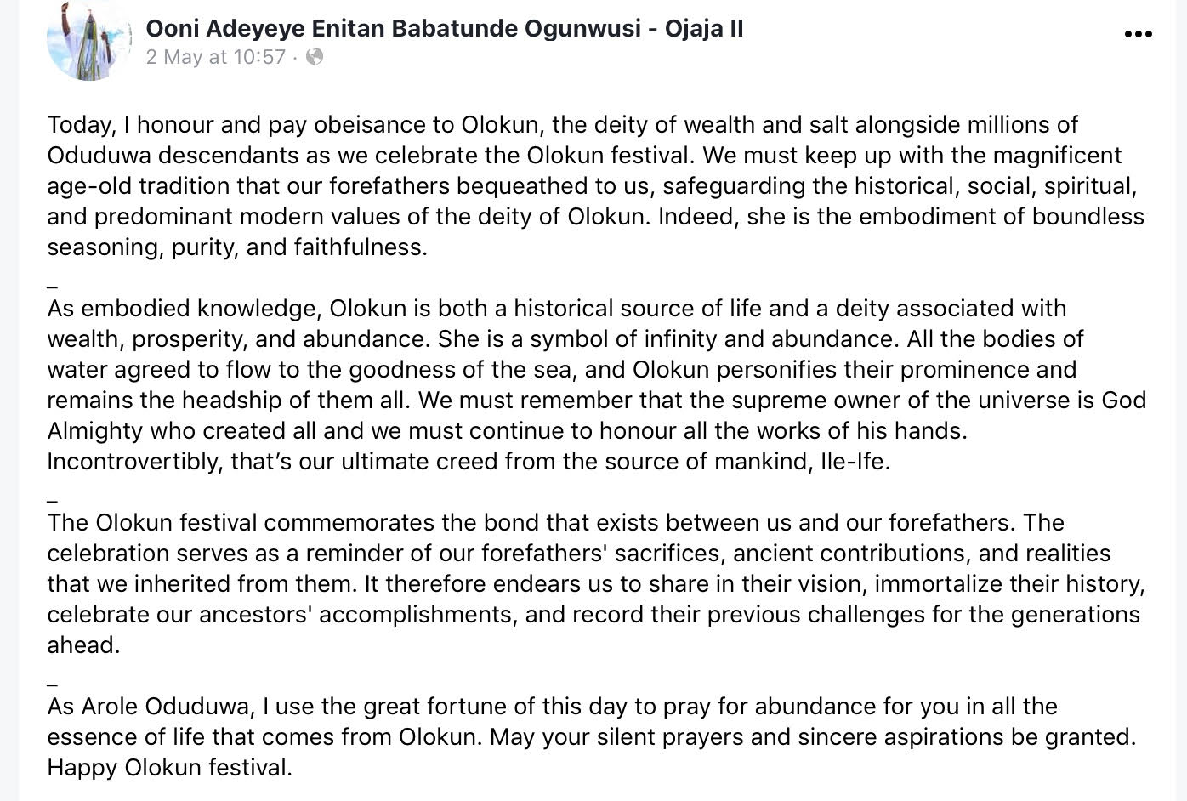

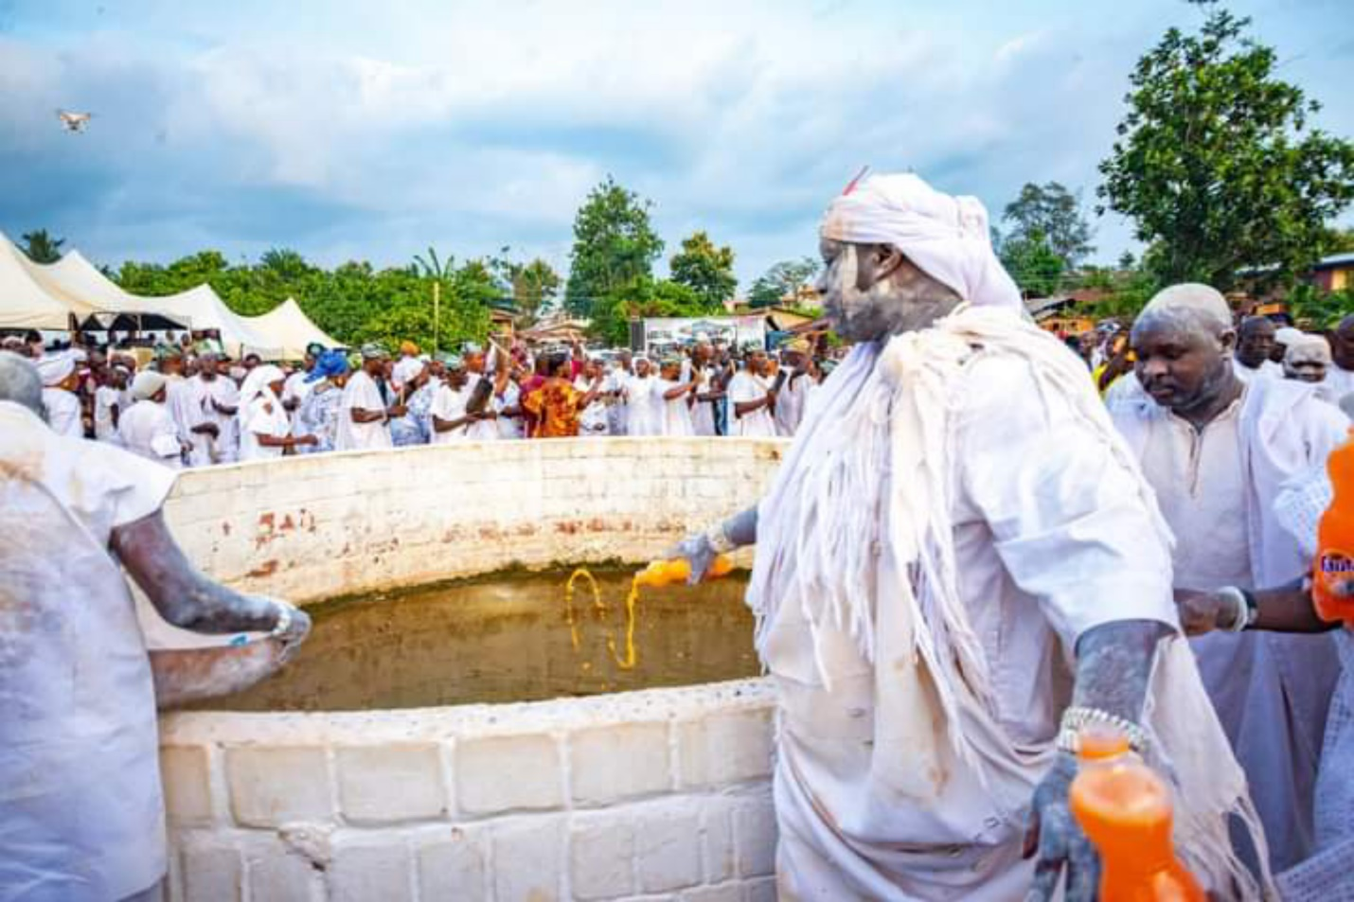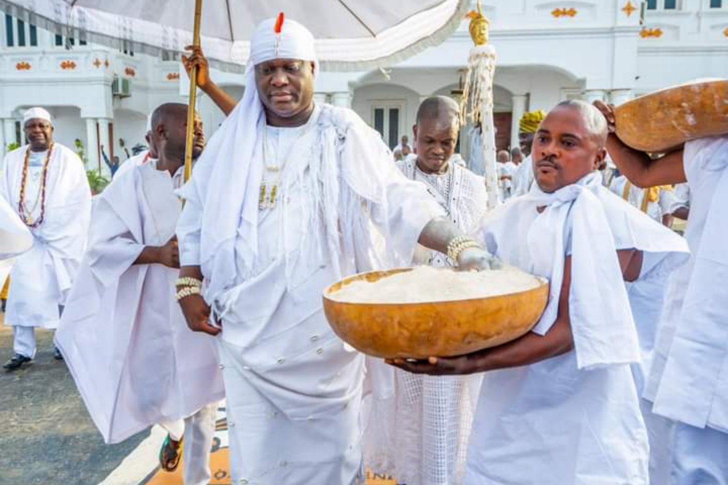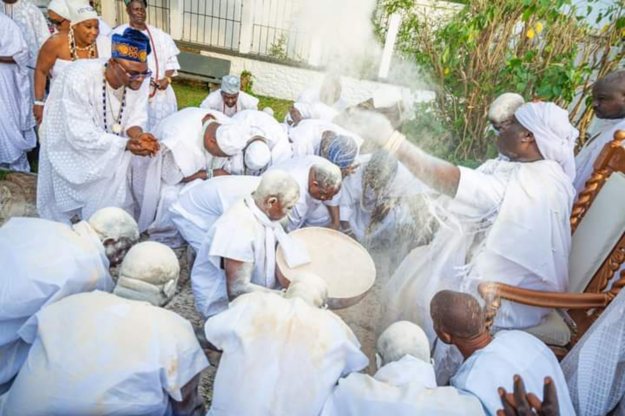

* Picture 1 is a post made on the Ooni’s Facebook page in commemoration of the Olokun festival
* Pictures 2 – 4 taken during the recent Olokun Festival held in the month of May 2022, at Ile-Ife. Cc: Ooni Adeyeye Enitan Ogunwusi – Ojájá II
* Red arrow shows the 51st and current traditional ruler and spiritual leader of the Yoruba kingdom of Ile-Ife; Ooni Adeyeye Enitan Ogunwusi – Ojájá II, also known as Ooni of Ife; performing acts of spiritual cleansing.